Fuel for Active Learning
It Starts with School Breakfast

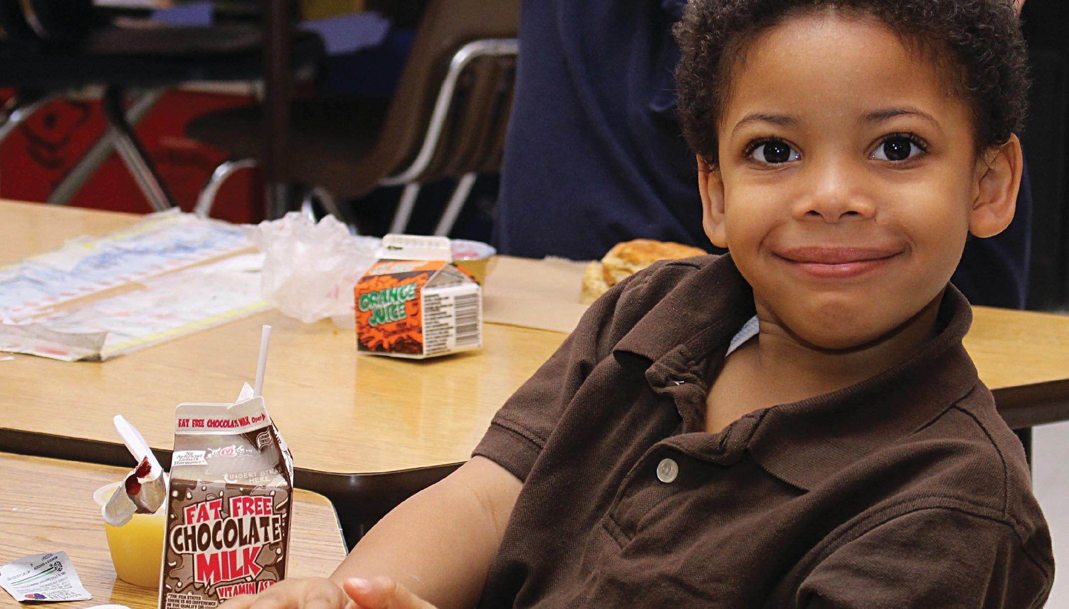

Bring on Breakfast...
3 out of 5 teachers say they teach kids who regularly come to school hungry 1

In our fast-paced lifestyles, many children are running out the door without sufficient fuel to start their school day off right. For the many families living on tight budgets, school breakfast provides an easy and nutritious meal. Children who eat breakfast are more likely to have adequate amounts of important nutrients like vitamin C, vitamin A, calcium, and phosphorus as well as consume more dairy, fiber and fruit.
Why to eat breakfast:
- Reduce tardiness, nurse visits, and absenteeism
- Improve overall academic achievement
- Increase time spent being physically active
- Help meet nutritional standards and aid in the fight against childhood obesity
- Fewer missed school days
Main causes for kids skipping breakfast:

- Hectic American lifestyle doesn’t allow for the time
- Lack of food in the house
- Only half of eligible kids participate in free school breakfast
Main causes for kids

Classroom Breakfast for a Smart Start
No child should start the school day hungry

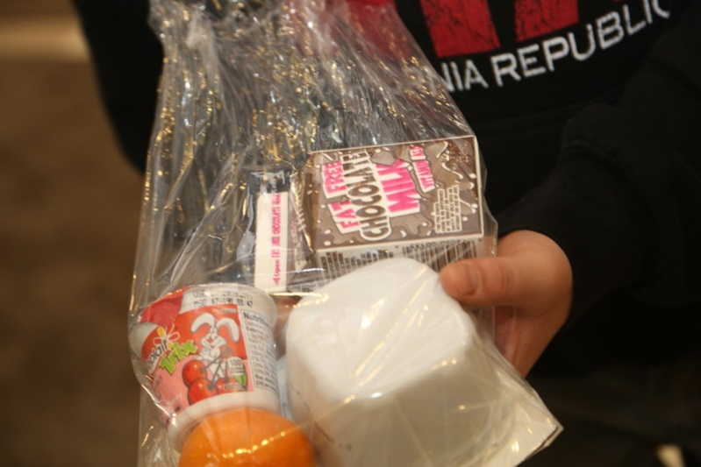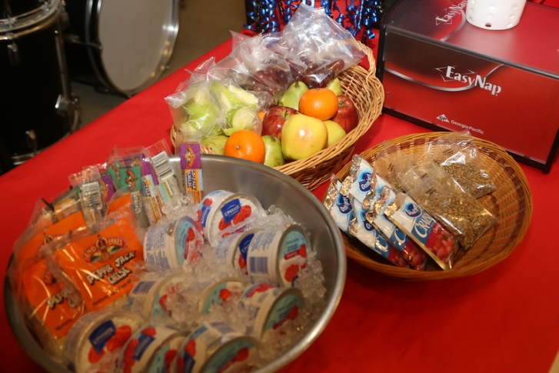
“Grab n’ Go” breakfast
Breakfast Menu

While breakfast remains to be the most important meal of the day only 13 million students consume school breakfast compared to the 31 million students who consume school lunch. Much of this is due to the stereotype that breakfast is for students who are certified for free or reduced priced meals. To help close the gap and move away from the stereotype, Midwest Dairy has helped schools across Iowa implement programs such as Breakfast in the Classroom, Grab ‘n’ go breakfast, and second chance breakfast.

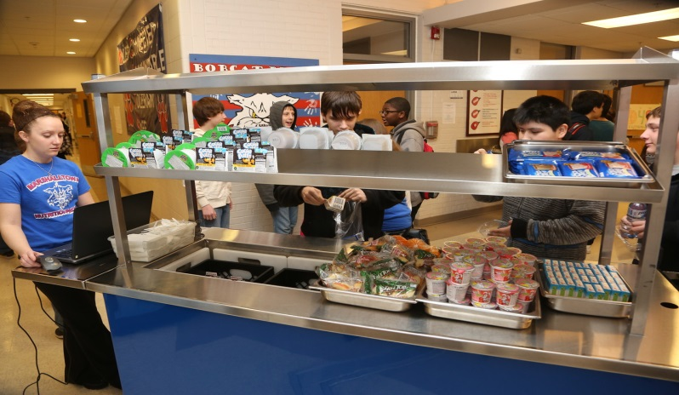
Nurses Help Hungry Students
When students show up in the nurse’s office complaining of headaches, stomachaches, dizziness, and fatigue, many school nurses observe that the kids aren’t sick—they’re just hungry.
“Grab-n-Go” Breakfast Station
A nutritious breakfast is packaged so students can quickly grab it from the cafeteria or carts elsewhere in the school. They eat it in the cafeteria, the classroom or on the school grounds in Miller Middle School.
1 Deloitte. No Kid Hungry: Share Our Strength. Ending childhood hunger: A social impact analysis. Deloitte Development Company, (2013)

